1. **Launch one EC2 using Amazon Linux 2 image and add a script in user data to install Apache**.

**Go to instance settings and find edit user data and then add a script.If it is running it is not allowed to add userdata.so we stop the instance and add userdata**.

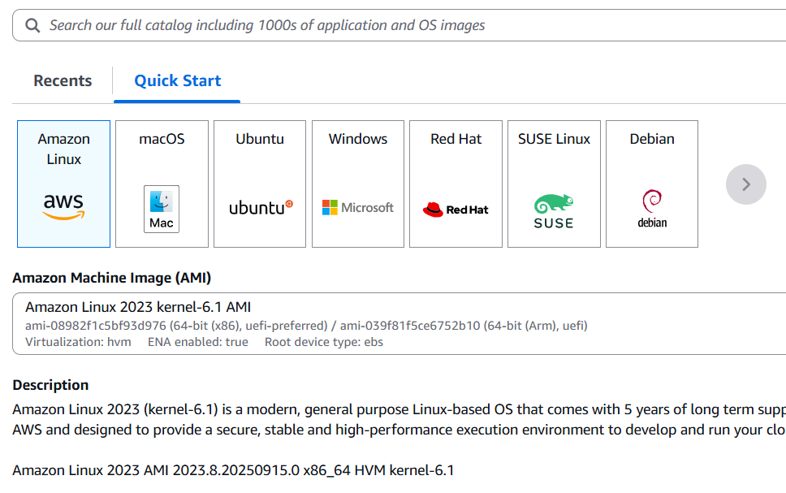

**Go to advanced security details and add user data.**

#!/bin/bash

# Update system

yum update -y

# Install Apache (httpd)

yum install -y http

# Enable Apache on startup

systemctl enable httpd

# Start Apache service

systemctl start httpd

# Create a sample web page

echo "<h1>Welcome! Apache is running on Amazon Linux 2</h1>" > /var/www/html/index.html

Then login into the server using ssh and pem key.

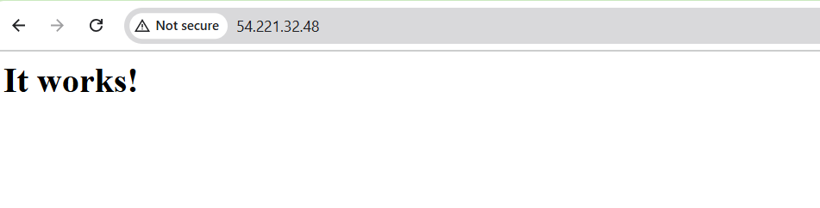

**2.Launch one EC2 using Ubuntu image and add a script in user data to install Nginx**.

**Launch the ec2 instance with ubuntu image**

**Go to the advanced settings add user data**

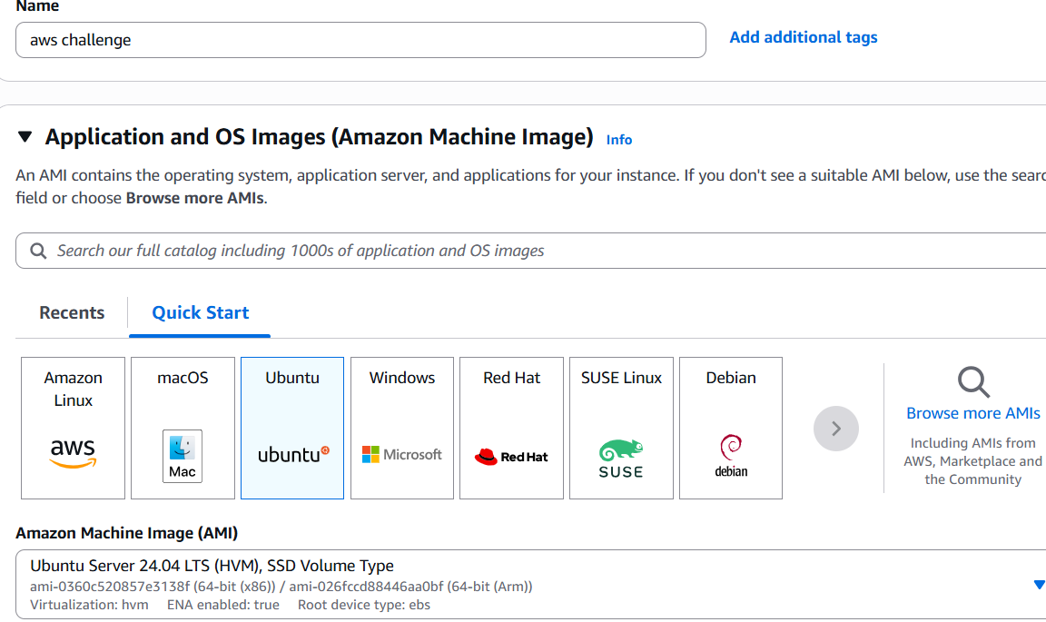

#!/bin/bash# Update package list  
sudo apt update# Install Nginx  
sudo apt install -y nginx# Enable Nginx to start on boot  
sudo systemctl enable nginx# Start Nginx service  
sudo systemctl start nginx# Show Nginx status  
sudo systemctl status nginx

**Then login to the server using ssh and pem key.**

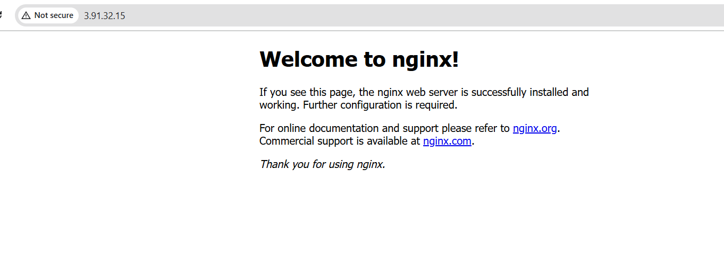

**3.Launch one Windows server and install Tomcat on Windows**.

Launch one ami image with windows server

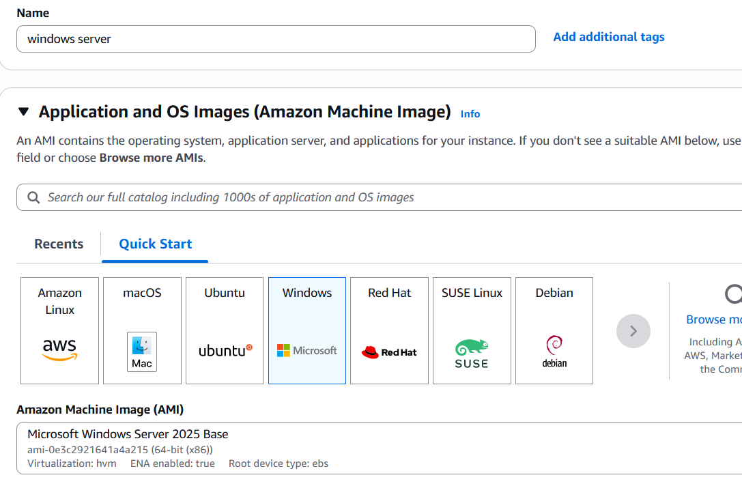

Add key pair and security details and save.

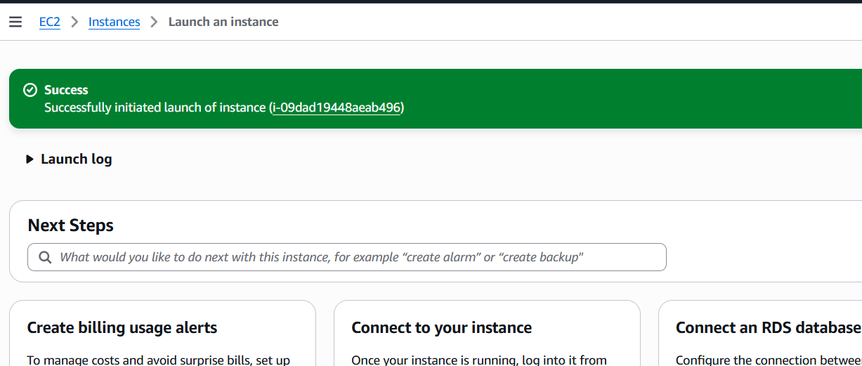

Go to RDP client and download remote desktop file and also encrypt the password.

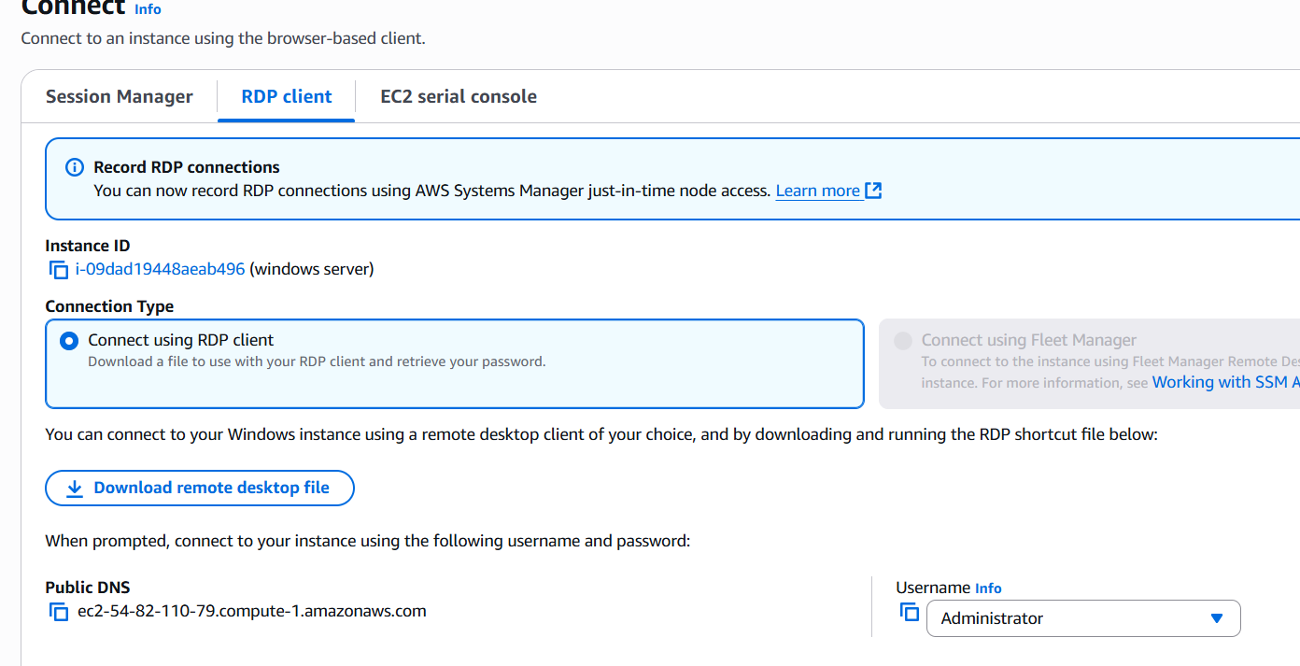

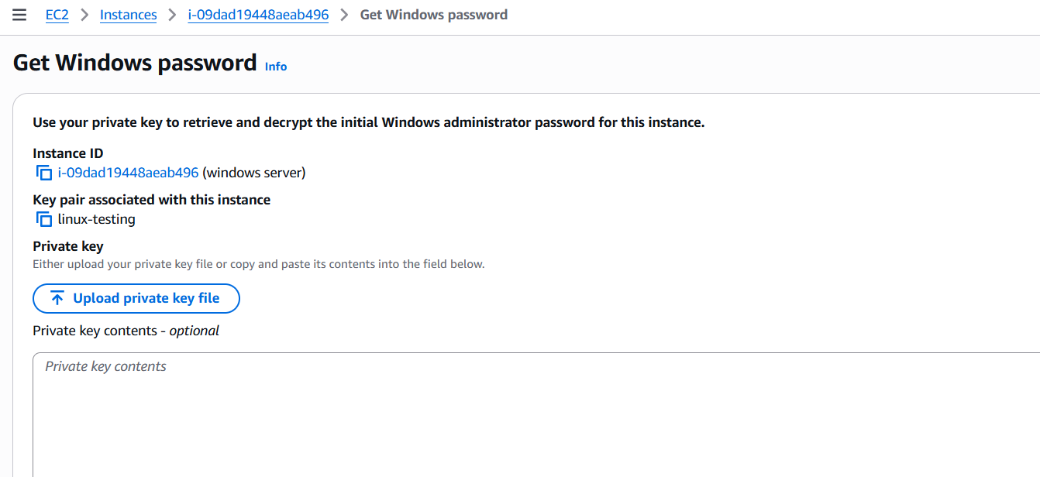

Click on remote desktop file and enter password we should login to the windows server.

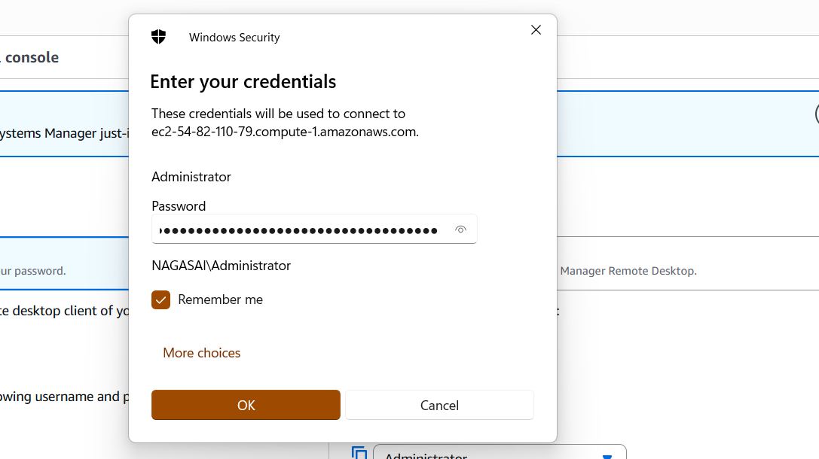

After login to the windows server install java and apache tomcat server.

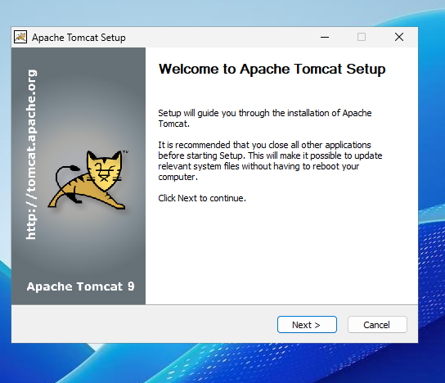

**4.Take a snapshot of the instance created in Task 1.**

Go to actions🡪create snapshot

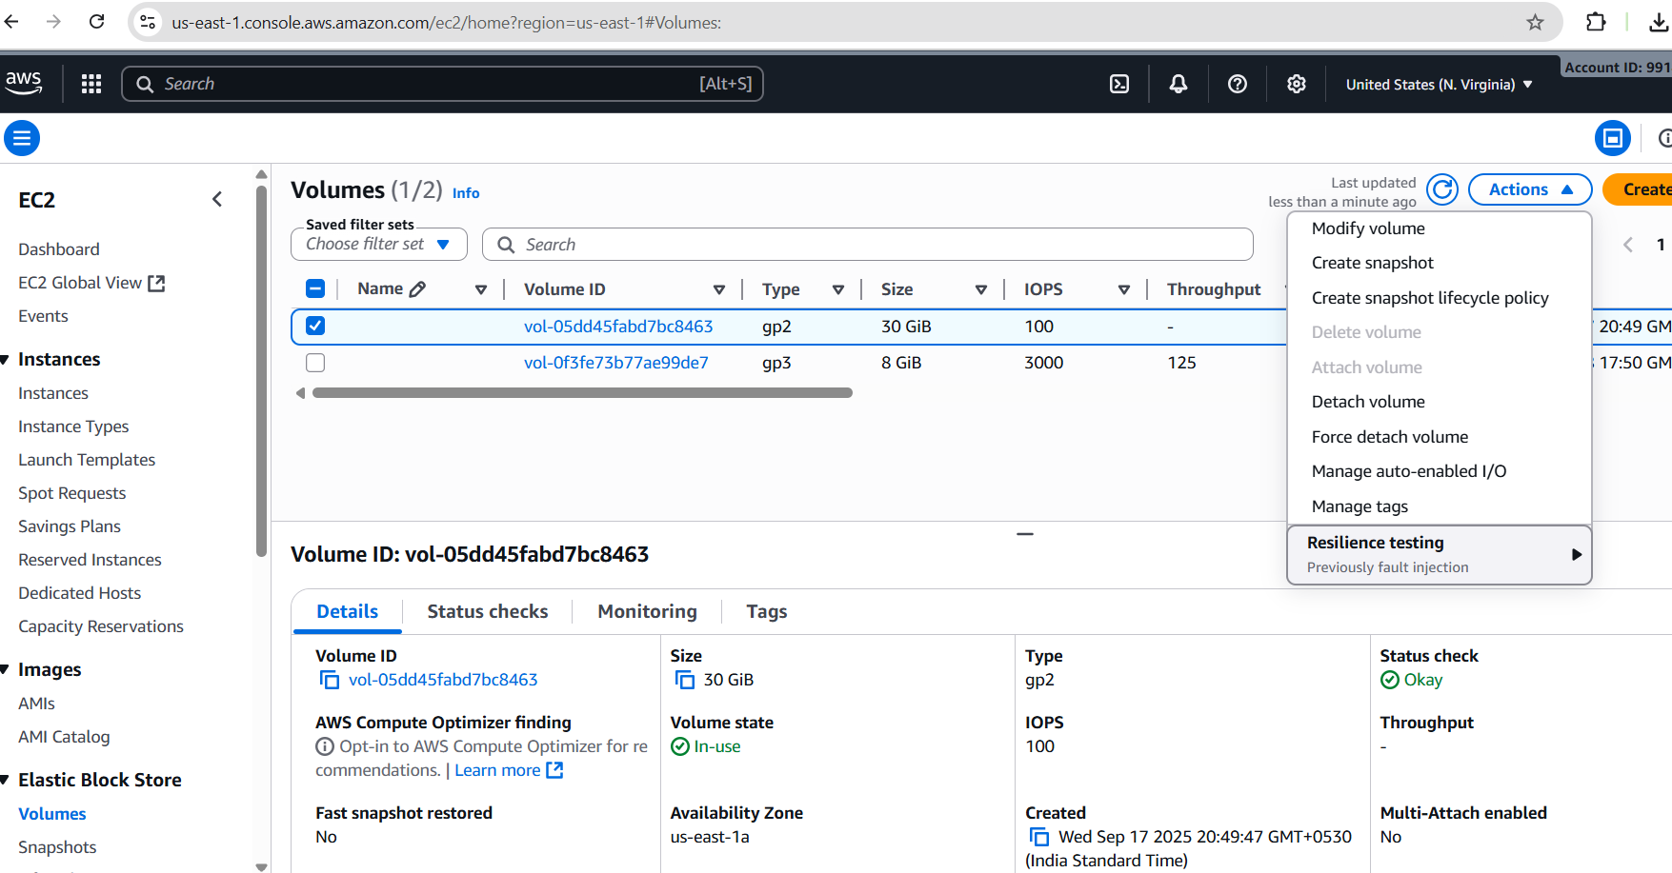

Enter details 🡪description-🡪create snapshot

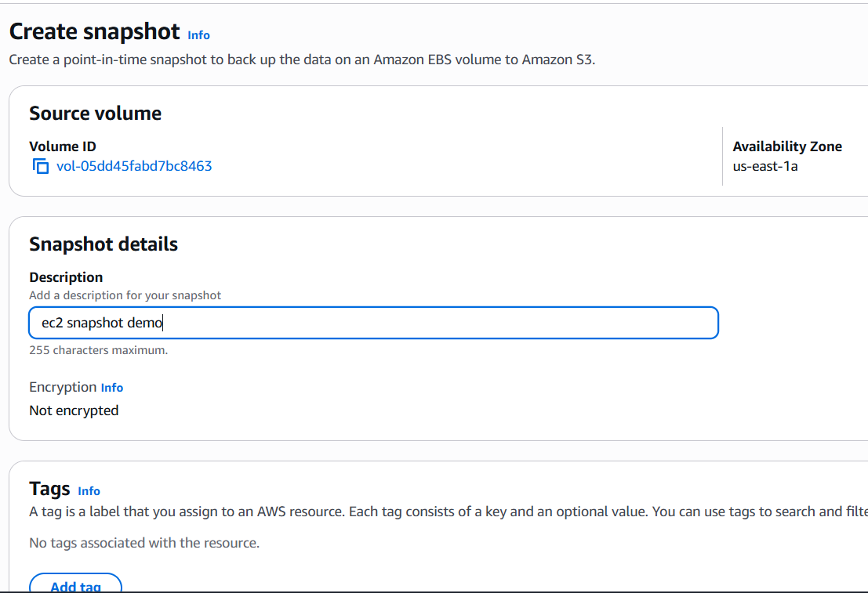

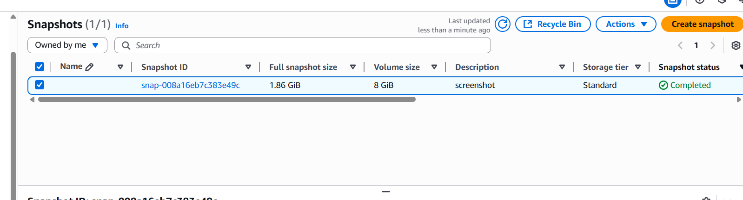

Snapshot was successfully created.



**5.Assign passwordless authentication for the EC2 created in Task 2.**

Ssh-keygen

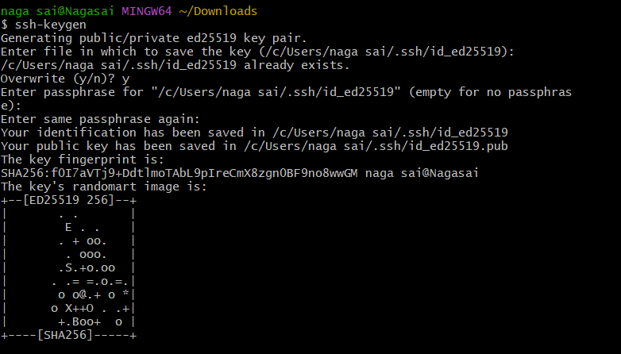

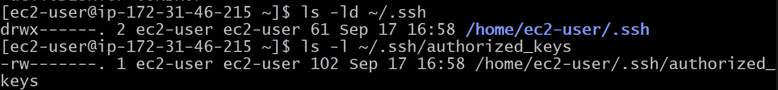

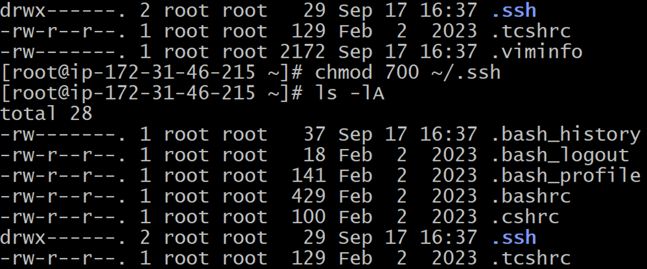

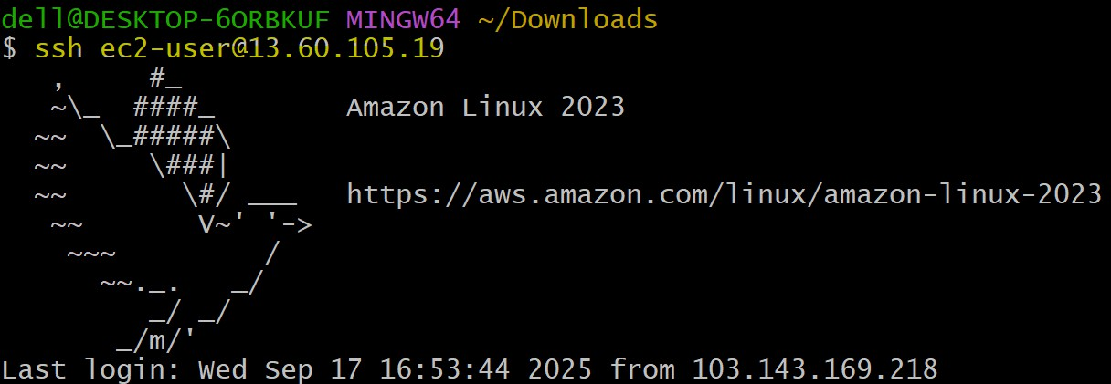

**6.Launch any EC2 using the spot purchasing option.**

Click on instances-🡪select ami 🡪select spot instance 🡪save.

**6. Launch any EC2 using the spot purchasing option.**

Go to ec2services🡪launch an instance🡪select spot instances🡪create instance.

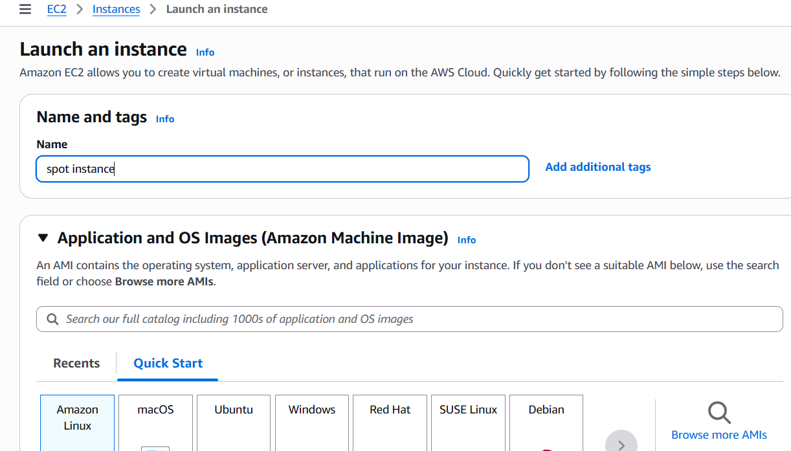

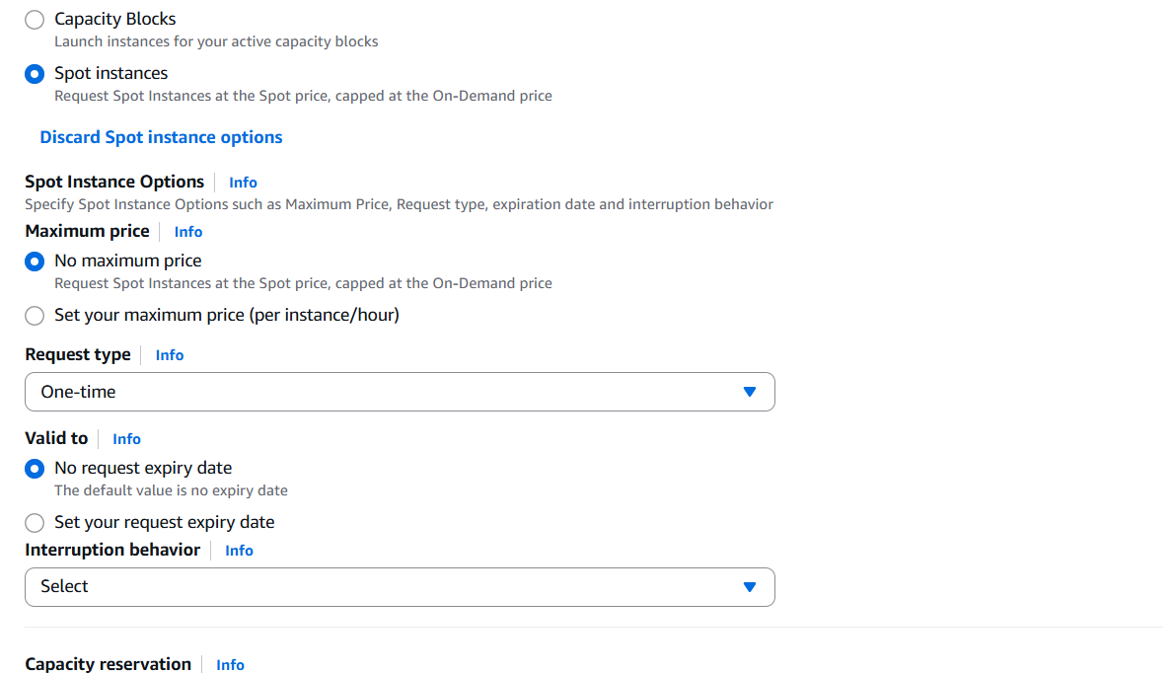

Successfully launch an instance with spot instance.

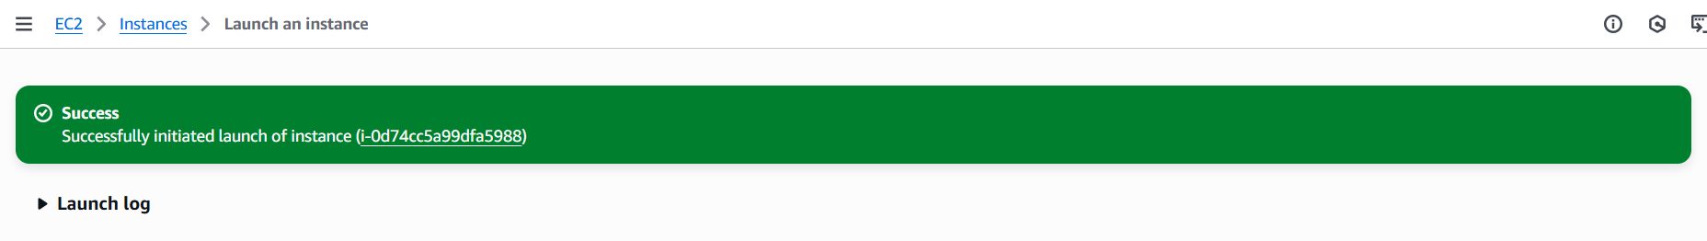

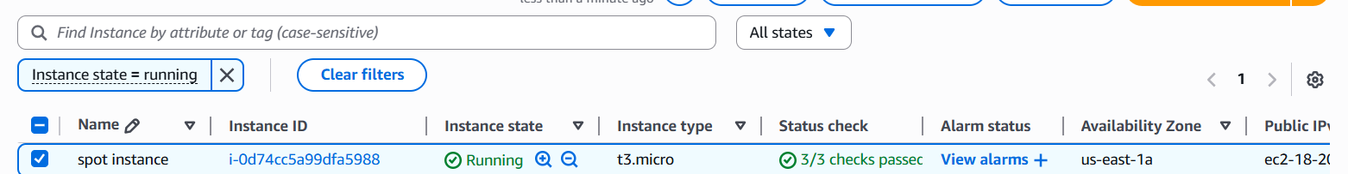

**7.Enable termination policy on the EC2 created in Task 2**.

Go to actions 🡪select change termination policy-🡪save**.**

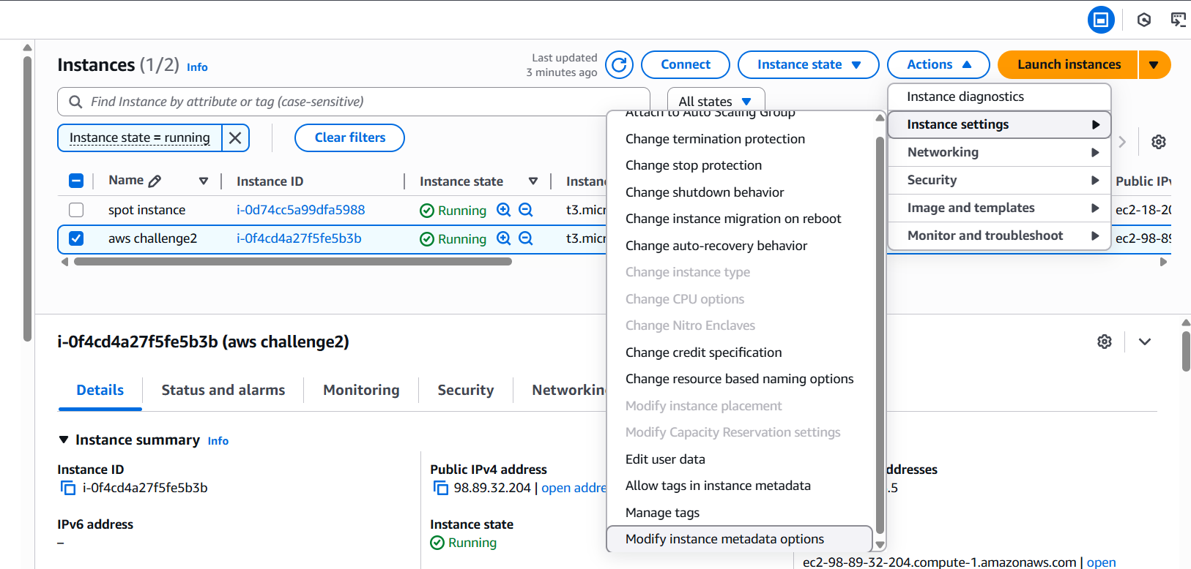

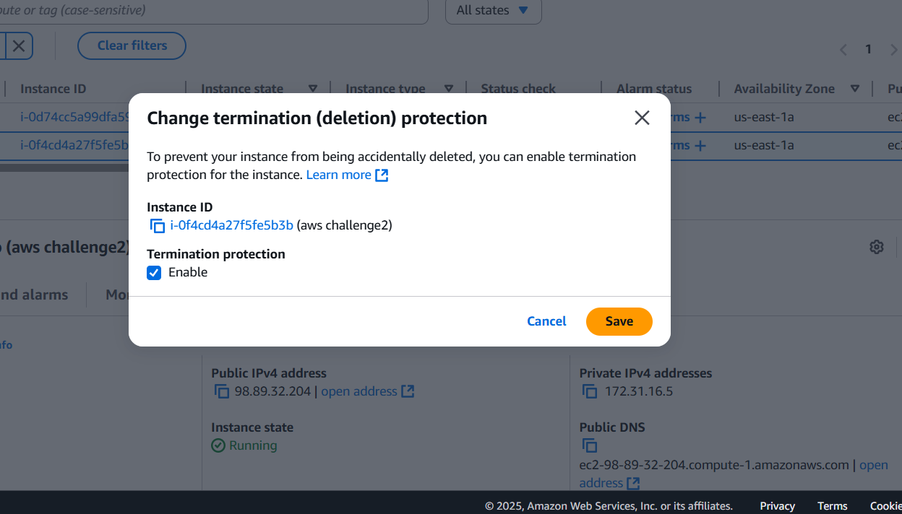

**8.Launch one EC2 using AWS CLI**.

¬Launch instance name with aws  
¬And connect to the server then  
¬Wget downlaod cli   
https://awscli.amazonaws.com/AWSCLIV2.msi  
¬Then gave a command of aws configure it will show uh   
a options like  
¬Access key  
¬Secret access key  
¬Region and format  
¬For accesskey and secreat key open our profile then   
security credentiols and it will genarate the keys  
¬Then aws ec2 describe-instances.  
¬Here the results

